Tanzania Food and Land Productivity Information System

Standalone version based on the “Trans-sec Virtual Box machine”

This document describes in short the use of the "stand alone version" of the Tanzania Food and Land Productivity Information System that was developed from 2014 -2017 for the Trans-SEC project.
This system can be run as a virtual machine using the free virtualization software "Virtual Box" (by Oracle). The user needs to install Virtual Box (and extensions) on their local system (host machine) - Windows, Mac , and Linux versions are available. Once Virtual Box has been installed the Virtual box user interface can be used to start the “Trans-sec virtual machine”. This virtual machine has been created based on the OSGEO v 10.0 Live Distribution (https://live.osgeo.org/en/index.html ) and adapted for purposes and requirement of the Trans-SEC project. In short the virtual machine is based on “Lubuntu” (a flavor of the Ubuntu Linux) operating system software that has specific adaptations for using geospatial software such as PostGIS, MapServer, and GDAL/OGR. The virtual machine also includes other GIS software such as QGIS so it can be used for extended lab/exercise sessions supporting GIS works flows.
Below is the workflow to get the Virtual (guest) machine started:

- Install Virtual BOX + extensions
Best is to use the copy of the software provided on this USB drive
Alternatively you can download them from here
https://www.virtualbox.org/wiki/Downloads
e.g. for windows
http://download.virtualbox.org/virtualbox/5.1.20/VirtualBox-5.1.20-114628-Win.exe and
Extension for all systems

2. Download and unzip the “Trans-sec Virtual Box machine”
Size is 5.5 GB zipped, unzipped it will be 16.5 GB big on disk
www.terragis.net/terragis.net/docs/other/tsec_live_copy.zip

3. Start the Virtual Box Software and load the “Trans-sec Virtual Box machine”
Menu: Machine > Add > tsec_live_copy.vbox
Click on green start button (see below)

Notes
Following the workflow above you will have a virtual machine running on top of your local operating system. If all works correctly you should be able to ‘drag and drop files from the virtual machine to your local drives (for example results created with the Land evaluation Tool).

Screen resolution issues
Often users might experience some problems with adapting the screen resolution of the virtual box machine. This is due to a virtual box configuration problem that has to do with a configuration file “VirtualBox.xml” that has incorrect settings after the required installation of the virtual Box extension. We have found that the following steps often will resolve these issues successfully:
Windows
On your host windows machine (not inside the virtual machine) find and edit the file VirtualBox.xml with a text editor (e.g. notepad)
This can be usually found under c:\Users\”your_user_name”\.VirtualBox\VirtualBox.xml
For example if the user name is “admin” this file would be
c:\Users\admin\.VirtualBox\VirtualBox.xml
Find the entry for the “allowed” screen resolutions “GUI/MaxGuestResolution”
And change it to the value “any”
<ExtraDataItem name="GUI/MaxGuestResolution" value="any"/>
Save the file and restart the virtual machine

Mac (alternatively these steps can also be used in Windows instead of the option listed above)
Open a command prompt and run this command to change the settings:
VBoxManage setextradata global GUI/MaxGuestResolution any
and press enter
On windows if the utility VBoxManage is not found (not in the executable path) you will need to add the directory path to it .for example
c:\Program Files\Oracle\VirtualBox\VBoxManage.exe setextradata global GUI/MaxGuestResolution any

Once the virtual (guest) machine started you might need now to adapt the screen resolution as well on the on the guest (in Lubuntu): 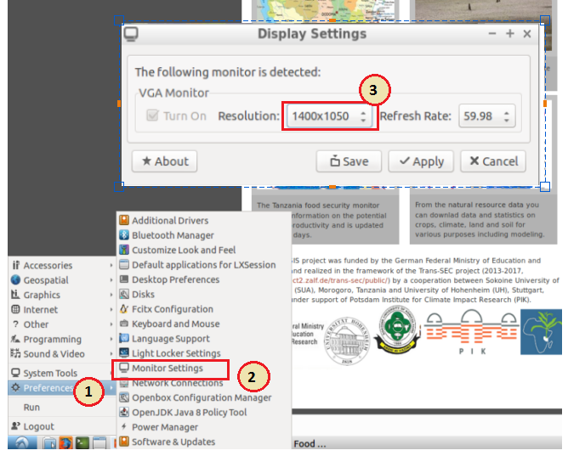
Go to the program button on the lower left hand side of the screen and click on it.
Go to Preferences > Monitor Settings
In the window that opens set a suitable resolution and click on apply. If the resulting display seems to look good on your desktop (nothing clipped off) click on save. The next time your virtual machine starts it will honor these new setting. You can changes these settings again in the future if they are not working well for you.

Finally one more note about the Virtual Box (guest) machine:
There are two operating modes ‘full screen mode’ and ‘scaled screen mode’
(resizable window that should scale).
To switch to ‘Full Screen mode’ use one of this short cut
“Host key” (on German keyboard Strg-rechts) + F

To switch to ‘scaled screen mode’ use one of these short cuts
“Host key” (on German keyboard Strg-rechts) + C
“Host key” (on German keyboard Strg-rechts) + L

For more options and to open the virtual box menu on top of the running virtual
machine:
“Host key” (on German keyboard Strg-rechts) + “Home” (on German keyboard Pos1)

